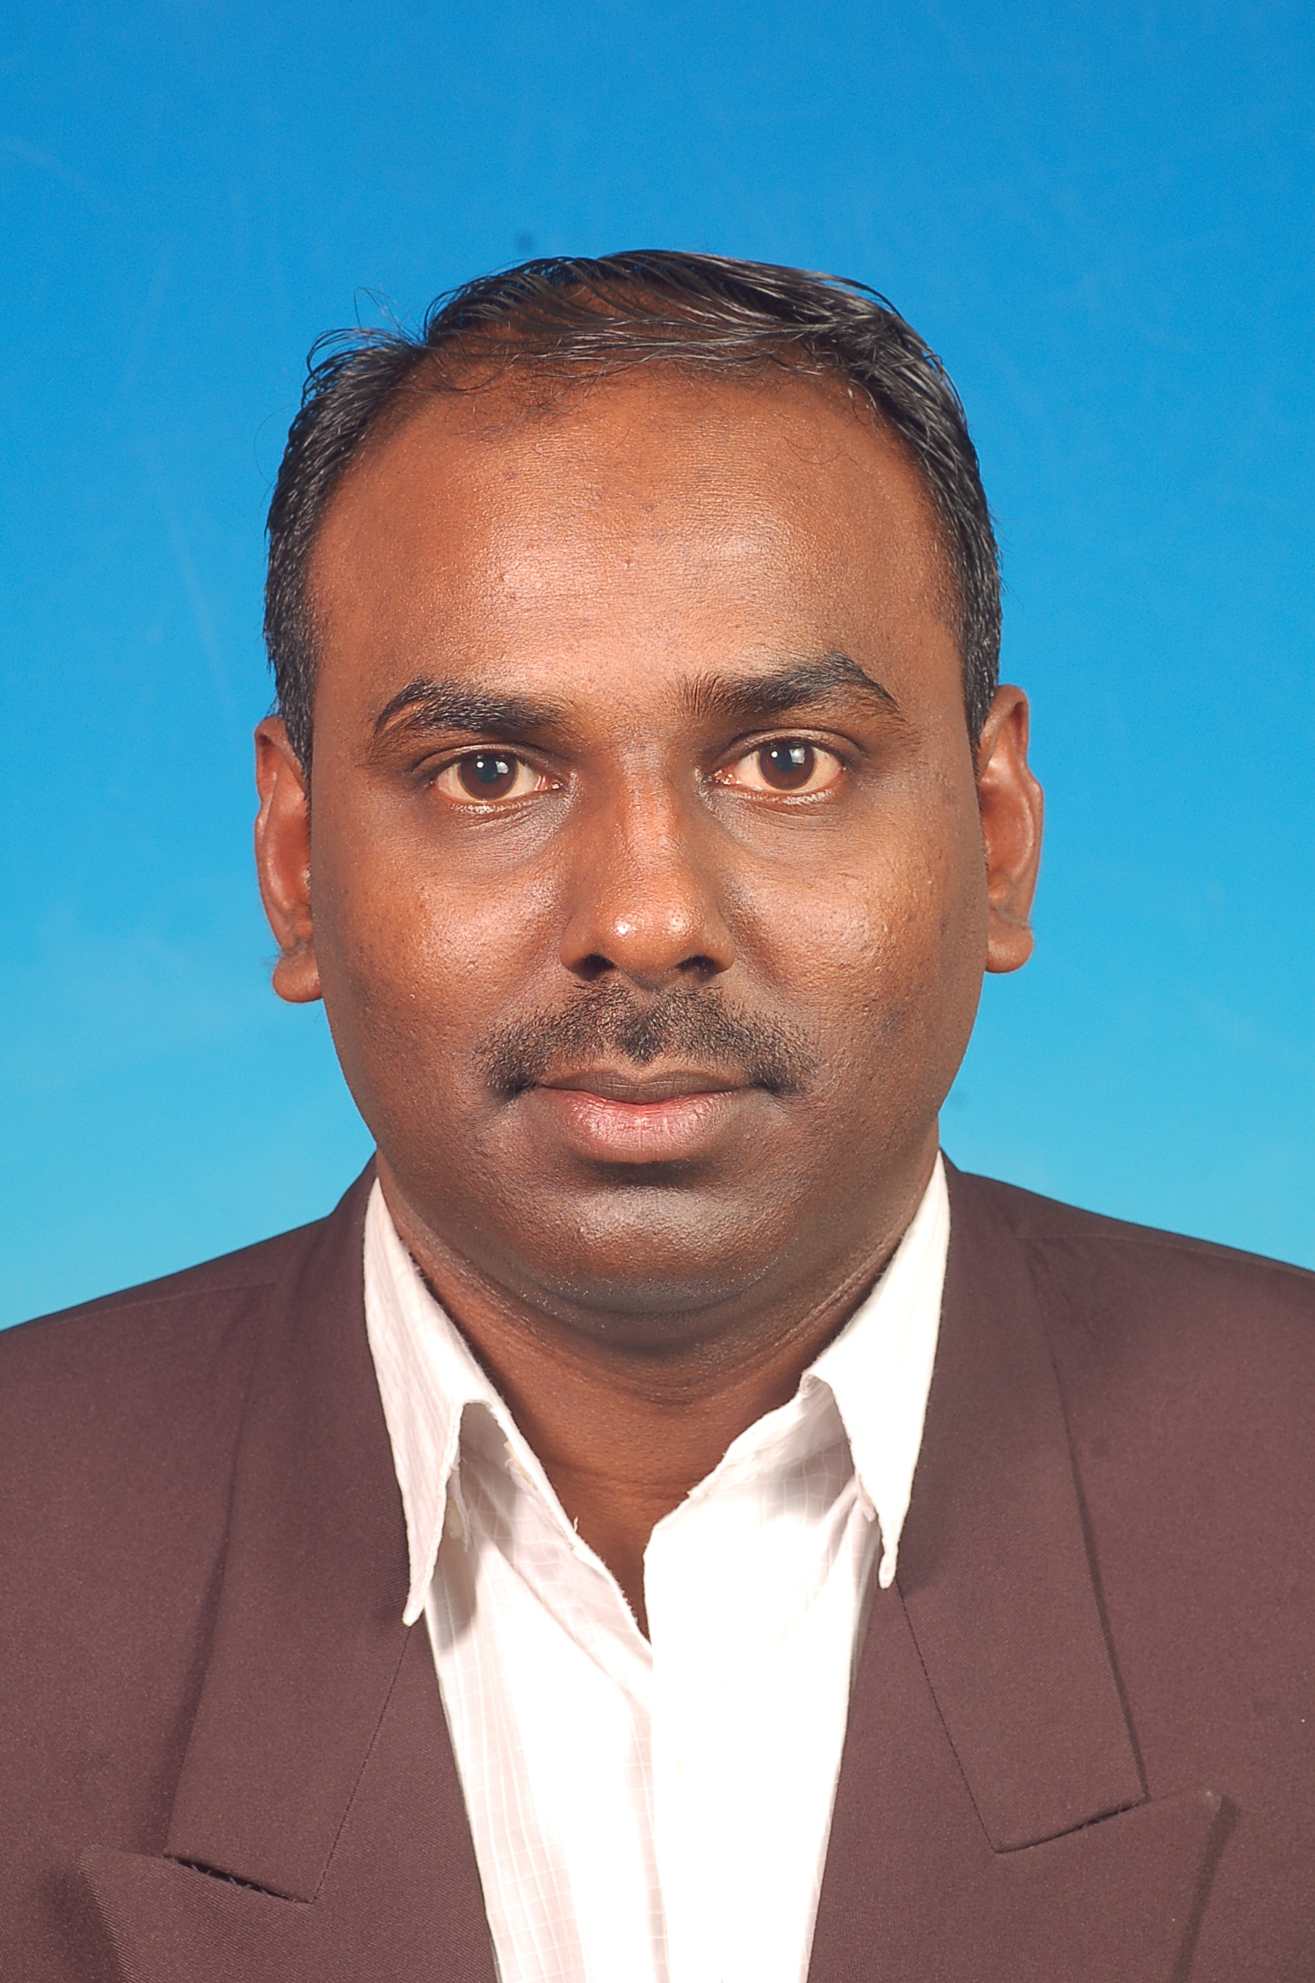

PERSONAL Name : Chandran A/L Soosai Kolundaisamy

DATA
Address : N0,32,Lorong 10
Taman Markisah
14000 Bukit Mertajam.
Penang.
Identity Card : 770202-07-5643
Sex : Male
Birth Date : 02-02-1977
Age : 37
Nationality : Malaysian
Telephone : +6-012-4641083 (Mobile Phone)

E-mail : chn_chandran@yahoo.com

ACADEMIC IATC – Nov, 1997 – Jan,1998
Certificate in Programmable Logic Controller

Institut Teknologi Kejuruteraan Midas

Certificate in Basic Computer
Certificate in Keyence Sensor Training

Prima Link Training and Consultancy

Certificate in Introduction to Total Preventive Maintenance

College Rifa

Diploma In Electric & Electronic(Jan1998-Dec2000)
Certificate in 7qc tools (2008-2008 2days)

ACADEMIC AXON-HCL
SAP Consultant certification MM(Oct 2008 – Feb 2009 )
ALL ASIA TALK
Knowledge in CCNA Certification(2009)
REDYNAMICS
Knowledge in MsSql Database 2005 Administration Certification (2010)

LANGUAGE Written Level
PROFIECIENCY English & Bahasa Malaysia Excellent

Spoken Level
English & Bahasa Malaysia Excellent

PROFESSIONAL
EXPERIENCE Smart Modular Technologies Sdn Bhd (1998-2010) SMT Technician – Smart Modular Technologies
SMT Technician & Programmer& Assistant Engineer – Smart Modular
Nichbei Parts Sdn Bhd – Plastic Stamping (2010-2011)
Production Assistant Executive – Nichbei Parts
Jabil Circuts Sdn Bhd (2011-Present)
Npi Qe Assistant Engineer
LEXI CONSULTANT(2013-Present)
BOM ANALSYST(CASUAL WORKER)

JOB FUNCTION Smart Modular Technologies (1998-2010)

Experienced in handling Machines such as DEK 265,DEK 288, DEK 265 Infinity (Solder Paste Print Machine)
Experienced in handling Panasert MV2F and Panasert MSR
Experienced in IC Placer such as MSF and MPAV
Experienced in Oven such as BTU Vip 98 and BTU Paragon
Lead NPI Team and do programming for machine
Running Memory,Lead free(ROHS), Embedded (FORCE COMPUTER) and
Flash Product
Lead the NPI Team to increase the Machine Capability
Quick Troubleshoot Machines to avoid any unnecessary Downtime
Manufacture Quality Products
Dealing with Vendors to Improve the Output
Hands – On Experience in most of the SMT Machines
Lead the NPI Team to Run Production in a smooth way
Monitoring the process yield
Study the process and improve process
Create a loading list for new product (NPI)
Do a program modification when there is ecn
Use sap system to do Bom comparison and check for any bom update
Prepare a first article inspection report for the product
Knowledge in SPC.FMEA, process control parameter
Perform line audit to ensure production running smoothly
In-depth analysis of BOM at component level for npi model.
AXON-HCL
SAP Consultant certification MM(Oct 2008 – Feb 2009 )
(educational and job function in training)
Setting up enterprise structure for business process.
Understand business requirements document prepared by on-site
coordinator
Responsible for MM Configuration and Mapping Requirements.
Prepared customization document
Unit testing and preparing documents.
Coordinating with all the other required modules to discuss and sort-out the
integration related issues
Master data Migration – Material master, Info records, Vendor master
(Purchasing view), source list and Condition records
Timely resolution of end user queries and if necessary, proactive discussion
on critical issues with users.

Nichbei Parts (2010-2011)
Ensure production target is achieved and increase productivity
supervise and plan daily operations in production and arrange man power
to generate the output report
Assist Production Manager for routine production activity
liaise with others internal colleague on other daily issues
Material planning for production running
Production planning to run in smooth way
Do a machine set up for product
Assist engineering in process improvement

JABIL Circuit (2011-Present)
Preparing readiness for npi prior to build
Attend for npi meeting for make sure all parts in place prior to build
Preparing deviation and avl parts matrix if there is needs for the product
Scrap the bom for Mpn buy off (manufacturing part n0)
Line buy off before running npi follow with checklist
Verifiying the ic ,bga and critical parts is same in bom , deviaton and avl parts
First article inspection for the first boards checking the comp polarity versus
With va or customer specification
Take note if there is any design issue, process and comp design issue to
Track in post mortem report and responsible to sove the issue.
Involve in 8D reporting and discussion
Daily yield reporting
Assist engineer to run npi in smooth and other related issue to solve in line.
Do the purge activity
Do the bom analsyst before run npi to check part n0 and other details
Prepare dev matrix and execute when running npi
Set the 999 message
Responsible for auditing line as the IPQC & IQC do the inspection as per
Standing operation.
To educate and train the IPQC for the new product introduction for
Inspection.
Responsible for rema return for validate and for dispostion.
Involve in quality improvement project.
Cordinate and communicate with customer for customer complaint and any
Any issue for the product for improvement.
In line root cause analysis,corrective and preventine action this involve all
Department when there is reject or reject found by customer.
Use a caliper for product mesurement.

LEXI CONSULTANT
BOM ANALSYT(CASUAL WORKER)
Manage end to end activities related to client Bill of Materials
In-depth analysis of BOM at component level
Identification of opportunities for BOM consolidation at component
level
Identify areas for standardization of vendor and manufacturer base
where applicable)
working with engineering components and PDM systems or in the
design department
Collaborate with functional departments (Engg. & Production) on
Operational Issues for client (EMS/OEM)
Handling different types of BOM structure& build up document
structure
Engineering consultation for client(If needed) on
Bom (scrubbing) and process Management in manufacturing.
Any other engineering work assign by Lexi management.

RESPONSIBILITIES

1 TAKE CARE PRODUCTION LINE PERFORMANCE
2 MAITAIN PRODUCTION QUALITY AND QUANTITY.
3 PERFORM PREVENTIVE MAINTENANCE ON MACHINE
4 PERFORM MACHINE DAILY CHECKLIST
5 REDUCE MACHINE DOWNTIME .
6 REDUCE MACHINE DROP OUT PART
7 FULLY ATTENDENCE ON WORKINGDAY.
8 FlEXIBLE ENOUGH TO ADAPT NEW ENVIRONMENT AND NEW
CHALLENGE

Current Salary RM 2833.00(nego)

Expected Salary RM 3000.00(nego)

REFERENCE Thavanessan
CONTACT N0 +6-016-7890167

